Oops, I Did It Again!
Matthew Vienneau
Matt Vienneau's report contains some mature themes. Reader discretion is advised.

Introduction
Jeff Donais: "Based on previous performance and skill, who do you think has the best chance to win Grand Prix Detroit? You are not allowed to pick yourself."
Nate Heiss: "Since Finkel isn't here, I will guess Matt Vienneau."
- From the Sideboard Q & A
Obviously Nate Heiss has great wisdom and insight into the game of Magic!
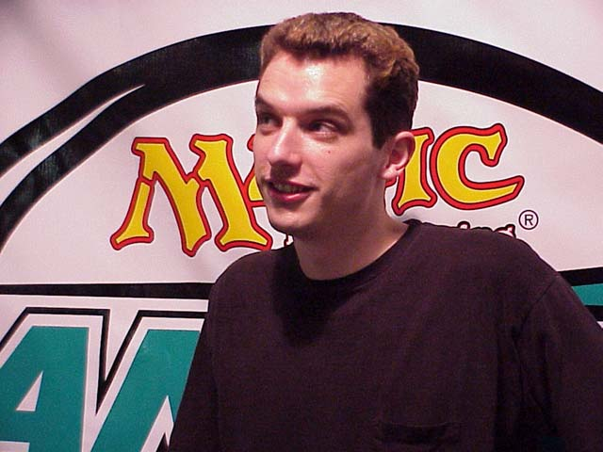
The thinking man's player, Matt Vienneau
I'm going to start this epic with a quick review of Grand Prix-Boston. I didn't write anything about Boston at the time about due to my, um, disappointing fourth place finish. I'll then cover my GP Detroit sealed deck and the complicated options involved in building and playing it, followed by dramatic turn-by-turn coverage of each of my booster drafts. Those of you already reaching for your "Back" button, STOP. Don't touch that button! I'm just kidding about the turn-by-turn thing! I don't think anyone could handle fifty pages of "land, go, land, go, land, go!" I'll cover the interesting points in the draft and subsequent matches, followed by the gripping excitement that was the Top 8 of one of the best Grand Prix ever!
I write two different kinds of tournament reports:
The type where I do well at the tournament and describe a lot of the strategy and key plays I used as well as other useful Magic information;
The much more interesting tournament reports where I do badly and people write to me about saying, "that's the best report I've ever read and I agree, you DID get screwed!"
Unfortunately the more interesting tournament reports, which frequently involve some sort of nudity, getting threatened with disqualification, and at least one brief celebrity appearance are getting rarer and rarer as I do better and better on the Tour and avoid playing in Europe (or as I call it - "Hell"). Let me reassure you, the reader, that I'm doing my best to lose as much as possible so my tournament reports are more interesting, but until that happens you'll be forced to read about the good times. If you want to read about losing, go read a Gary Wise Grand Prix report! For those of you desperate to have your fix of "Matt did badly at a Magic tournament," be hopeful - Pro Tour Barcelona is almost definitely going to be held in Europe (unless it suddenly gets moved to Columbus!) and I *never* do well if I've had to cross the Atlantic. Be prepared for a fantastic report that will no doubt feature the antics of overzealous English judges, vacationing rock stars and clothing optional beaches! What tournament report doesn't get better if you add a couple of topless beach stories?
I've also noticed that I've developed an affinity for formal lists. My thoughts tend to wander and I'm trying to keep my thinking clean and clear and I find lists really help for two reasons:
They're easy to read;
They're easy to write.
So expect more lists than usual, but as we just found out, that will only make things easier for you!

The Prequel - GP Boston
Lucky you - you get a second mini-report absolutely free! What a deal!
Way back in October last year, I managed to squeak out a victory at Grand Prix Dallas by going 15-1. I wrote a report at the time (you can read it here) where I expressed the opinion that I got really, really lucky. All my opponents got mana-screwed, I drew the lands and spells I needed when I needed them and things just went my way. I didn't expect that I'd do even close to as well at the next Limited event I would go to. This was born out by my 92nd place finish at PT LA that I blame solely on all the people who aren't from North America. I can apparently draft North Americans under the table, no matter what the format, but once Europeans and Asians gather to draft with me, my brain decides it's time to take a nap.
But in GP Boston, something weird happened.
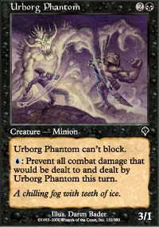
Unstoppable?
I got an absolutely horrible sealed deck on the first day (that isn't the weird part). This isn't like my "I think my deck is really weak but oops, it managed to go undefeated because of all the removal" like in Dallas, this was a really weak deck. I have witnesses! I practiced with the deck for the entire three rounds of byes and I wasn't able to beat anyone other than Donnie Gallitz's four-color "special." I asked Gab Tsang for comments on my deck and he pretty much agreed that I was beyond help. I had a mediocre Black-Blue-White deck that I could instantly transform into a mediocre Black-Blue-Red deck that would beat down my opponents with the nearly unstoppable likes of Slimy Kavu and Urborg Phantom! Look out side tournaments!
But somehow I went 8-0!
I'm still not sure how I did it. Afterwards the cantankerous Randy B. came over and looked a the deck to determine the secret to my success and he just shook his head in wonder exclaiming "I can't write anything about that deck, it's absolutely horrible!" Somehow I had overworked and overplayed the deck into an 8-0 record. And once you're 8-0, it's pretty hard to miss top 8, but I almost did it by going 2-0-1 and then 1-2 with some mediocre draft decks.
The draft in the top 8 went amazing for me. My first pack revealed Stalking Assassin. A nice solid Black-Blue card that can wreck Green-White decks, excellent! I was then passed Stormscape Master and Faerie Squadron! This is an excellent signal to go Black-Blue-White and that's what Tom Swan (the eventual winner) on my right wanted me to do when he took Assault-Battery first. I took the Master (many disagree with the pick but I feel its blue ability can easily dominate games and passing it sends the wrong signals) and then got passed Fact or Fiction! I was pretty sure that I was in good shape for this draft with a deck full of strong but expensive spells, a theme I was to carry into the Top 8 in Detroit!
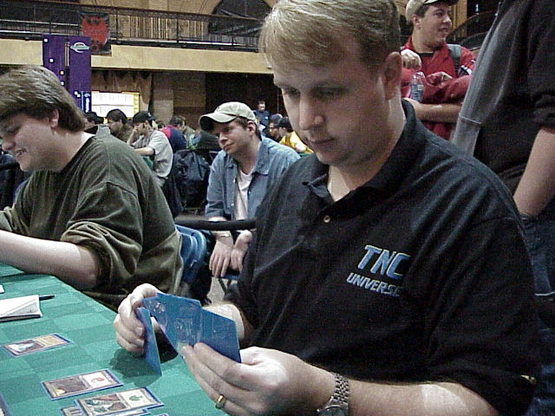
My amazing deck was eventually defeated by Scott Johns in the semifinals where I managed to outplay myself by somehow getting convinced that with four cards in hand, Scott must have something when in reality he had nothing and was hoping I did too.
I was a bit disappointed with myself for having played my way out of the Top 8, especially as I had really cut down on the game-losing play mistakes that made GP Dallas so exciting. Apparently in an attempt to avoid making massive player errors I overcompensated and ended up making strategic blunders. I really felt I had an incredible deck that was better than my opponent's (though I've given Scavenged Weaponry new respect after seeing Mr. Johns play it) but I lost. The tournament itself was so-so with a huge food problem (there was none - ever try playing a Top 8 without access to any decent food for the previous eight hours?) so I didn't bother writing a report. Who wants to hear the guy in 4th whining about how the tournament wasn't perfect? You have to leave something for the people in 500th to write about!

GP Detroit - A New Hope
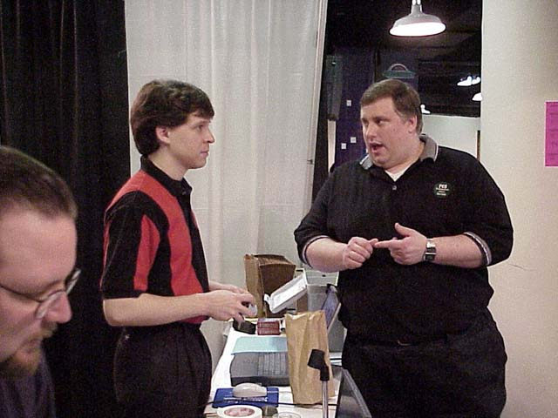
Head Judge Mike Donais and Tournament Organizer Mike Guptil
Grand Prix Detroit turned out to be the biggest sanctioned tournament EVER in North America. And heck, there may even have been bigger tournaments since then, but when I'm bragging to women and my mom I don't bother mentioning them. We all know how impressed the women get when you mention how large your Magic tournaments are! Luckily, the esteemed PES crew was prepared for enormous amounts of people and there was enough table space that one could play between Mr. Rose and Mr. Wise and still be able to stretch one's elbows. Mike Guptil really knows how to run a tournament and there was nothing I could throw at him that he hadn't already thought of, which is a pleasant change. The regular judging staff was adequate but probably require a bit more seasoning before I would throw them to the wolves at a Pro Tour. The head judge was, of course, the best head judge ever. The food situation was kind of a mixed bag. There was fast food readily available, which is incredible and so much more than what is offered at most big events. But the staff at McDonalds and Burger King were some of the worst I've ever seen and only those that define "fast" as "waiting only 20-30 minutes for simple orders" would be satisfied with the service. But it was better than eating nothing!
The best part of Detroit, of course, was that it was a four-hour drive from Toronto, the self-proclaimed "Best Place on the Planet to Live that Doesn't Have Topless Beaches" (Honest! - It's in the brochures!) There are few things as satisfying as arriving at a major event well rested with daylight remaining and a bounce in your step. Let me tell you, Worlds is going to be amazing this year!
The Grand Prix started about an hour after the advertised 10:15 start time. While I really, really enjoy the late start times of recent Grand Prix, it leaves only 6-7 hours for eating and sleeping at the end of the first day and that's way too few. I think everyone would appreciate starting the Grand Prix an hour earlier, even if that does mean a bit less sleep for the first day. The hour delay was excusable due to the incredibly large number of people showing up, though I'm curious why everyone and their byes weren't entered the night before? We'll have to import the Japanese (and Chris Zantides!) who can run a 600+-person tournament in only a few hours!
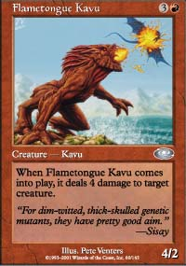
Despite the fun adventures of going undefeated with wacky decks at two previous Grand Prix, I was still hoping to get the absolute broken deck that I could comfortably ride to 8-0. In particular, I had noticed that all the top decks posted to the internet seemed to have Magma Burst AND Flametongue Kavu in them so it seemed that that was the core competency (MBA-speak!) required to do well at sealed events. Good players open multiple Red cards of quality. Despite this hope, I still rushed to the "Gold" section of the deck list to see which Dragons I would be riding to victory.
Despite dreams of riding to victory on the backs of Dragons as my foes burned beneath me, I would apparently be forced to walk to my battles as I had no Dragons or any fliers big enough to carry me. I quickly begin sorting the cards out in their colors to verify the deck list and notice that whoever registered my deck accidentally put in Rout and Crypt Angel but then crossed them out. I protest to the judges that it would only be fair to give me the Rout and Crypt Angel I so obviously deserve. The judges come up with some zany story that it would be extremely unlikely that my sealed deck would five Rares in it so I'm going to have to settle for the ones I got like Absorb and Sabretooth Nishoba.
But upon further review, I realized that my wish *had* come true - Flametongue Kavu and Magma Burst! Woohoo! And to make it even better, I had 23 playable cards in red and black! 23! A two color deck! Go Team Go!
My deck looked like this (with individual card analysis attached):
Terminate - Uh, good against creature decks!
Smoldering Tar - Uh, good against creature decks and in games where you have an opponent!
Plague Spores - Hmm, good against decks with creatures and land!
Magma Burst - Especially good against decks with multiple creatures!
Scorching Lava - Good against small creatures!
Tribal Flames - See "Scorching Lava"
Flametongue Kavu - So very good!
As you can see, my removal spells were excellent - what is there to say about them? I was probably in grave danger (is there any other kind?) if I faced one of the many players trying out creature-less sealed decks, but I remained hopeful that I would be able to avoid them in the undefeated bracket.
The rest of my cards are a bit more interesting:
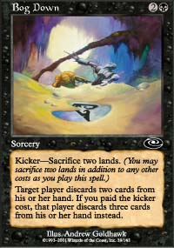
Do or Die - Surprisingly bad. With all the other kill spells I had the opportunity to do much more than kill their worse creature. At times I was actually holding back with kill so I could use Do or Die as I didn't want to spend the whole game holding it. But trust me, this is a problem I didn't mind having!
Mourning - Good for setting up the Do or Die, these little synergies are the key to getting 100% out of your deck.
Cursed Flesh - Well, not EVERY card can be interesting.
Bog Down - Often a critical card. Gary Krakower has mentioned how important this card can be when playing against superior decks, and I agree. It was the card I feared playing against the most, as it would always get two excellent kill spells. Every Black deck should play it!
Lord of the Undead - Amazing! I never really realized how good this guy was. In Black-Red versus Black-Red Limited matches you often hit situations where both of you have cleared off all the creatures and are just trying to top-deck something to start doing damage. This guy is a whole bunch of top-decks at once as he begins recycling all those creatures that were killed earlier. I believe I'll start picking him first and be happy about it!
Eleven Red and-or Black creatures - does it really matter what they are? Oh fine, if you must know, they were Phyrexian Reaper (zombie!), Lava Zombie (zombie!), Kavu Aggressor, Sparring Golem, Slingshot Goblin (the best creature in Team Rochester!), Hate Weaver, Ravenous Rats, Nightscape Familiar (zombie!), Firebrand Ranger, Kavu Scout (2/2) and Morgue Toad. The sideboard had Death Bomb, Keldon Mantle and Dredge but only the Death Bomb came in (against Sabertooth Nishoba).
In Black-Red decks, the creatures are rarely important, as long as there are enough of them that you can eventually start hitting once you've killed everything else on the board. The way the deck would win was casting a turn two and three creature and then removing every single creature my opponent played after that. The games that were difficult were where my opponent would have a way of dealing with those first two creatures at which point I lost momentum. I still would win due to the quality of my cards, but when building your deck it's often important to include the seemingly crappy 2/1 creatures with no abilities like Firebrand Ranger just so you can hit early.
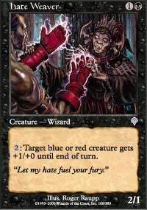
The Hate Weaver's ability never really became a factor as at the top tables you rarely have lots of creatures in play so the odds of having a red creature alongside the Weaver were slim. Sparring Golem was a surprise over-performer as it consistently was able to get through when my opponent played 2/2 creatures and could trade with the bigger threats to allow my 2/2s to continue the attack. The Kavu Scout was easily the worst card in my deck, but I didn't think I needed more kill so I didn't play the Death Bomb over it.
In summary, my deck was amazing! If I was undefeated with BAD decks, imagine how well I could do with this fantastic deck!
Well, uh, I actually couldn't do a heck of a lot better than undefeated, but you get my point.
This deck was actually better than both the Black-Red and Black-Blue-Red decks that I drafted on the second day. I would have gladly played this deck for the entire seventeen round of the tournament. I briefly considered a couple of other builds of the deck to make use of the Sabertooth Nishoba, Voice of All, Silver Drake and two tappers, but nothing was good enough for me to use.
I normally use my three byes to practice with my deck so I can get used to the feel of it and figure out any improvements that can be made after the first game. Normally this means I get my butt whipped for several hours, but this time it was a bit different as I beat the crap out of anyone who dared challenge me. The problem with doing this is that everyone else at the Grand Prix started to hear about my deck. For the rest of the day people would come up to me and ask "do you REALLY have two Terminates, two Flametongues and a Crypt Angel?" to which I would reply "who told you?" Hopefully this instilled great fear in my opponents, but I didn't notice anyone visibly trembling. As I didn't actually have the deck that was described, I can only hope that my opponents played around my non-existent Crypt Angel!

Round 4 Dan O'Mahoney-Schwartz

Dan's a cocky SOB with few redeeming features, but that just makes it more of a pleasure when you eventually defeat him due to his own mistakes. Of course, the same could easily be said about me!
The Sideboard covered this match, which is surprising as I rarely get a feature match until I'm a lock for the Top 8. I just don't "rate" in the excitement department for some reason. I think I have to be louder and more obnoxious! Jeff Donais writes about it in his own words here.
And he does an admirable job. I find the interesting part of feature matches to be the dialogue and personal interaction, especially in sealed deck matches. Unless there's some colossal misplay, or something really cool, who really cares about someone attacking with their Kavu Aggressor? But if someone calls someone else a cocky SOB, then people want to know about it! Jeff manages to fit more of the interesting parts into his feature match reporting.
** Aside on Sideboard Writers **
I know a lot of you read the feature match coverage, but do you notice who writes them? And if you like the coverage a lot, or notice a particularly well written piece of prose, do you write to the Content Manager about it? Having been one of the overworked peons who has slaved away under the harsh glare of the Sideboard's own Omeed Dariani, I can tell you that it would be great to hear good things once in a while! If you see something you like, email omeed@wizards.com and let him know! Or contact the writers themselves if you can find their email address. People want to be appreciated!
** End Aside **
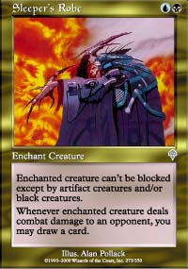
Dan fluked out in the first game as I didn't draw any of my numerous kill cards as he wrecked me with a Sparring Golem wearing pajamas (Sleeper's Robe) that eventually developed Sinister Strength. This didn't worry me, as I knew I would easily crush him in the next two games, but fate was unkind to me, as I was forced to double-mulligan in the third game. Even *my* deck would have trouble coming back from a double mulligan. Dan was all class as he pumped his fist and cheered with each mulligan!
Luckily for me, Dan has never read Eric Taylor's article on mulligans as he kept a hand of six land and a Hooded Kavu! You can read the article and avoid his stupid mistake by going here.
This article, in my opinion, is the defining article on when to mulligan and when to keep. The math clearly proves that you should always mulligan a six-land hand. Dan paid the price for his folly as he drew the expected number of lands after his opening draw and ended up with not enough spells. If you draw three land and five spells in your next six draws, you still have nine land and six spells and that's rarely a formula for victory. With his slow start and lack of aggression, I was able to come back and win the match. The good guys win!
Of course, since then I have twice kept six land hands and won, including once in the Top 8, but as Randy B. mentioned, I'm a trained professional! Don't try it at home!
4-0

Round 5 - Josh Rider
Aaah, easy prey - a fellow Canadian!
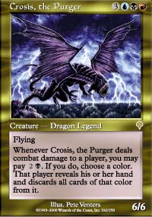
I figure Josh had a good deck as most people in the 4-0 bracket that don't have three byes have good decks. At one point, I'm dominating the board with three creatures to his none. I figure he has to be setting up for a Breath and keep some creatures in my hand. But he was actually waiting for a sixth land so he could play Crosis! Yikes! Normally that would mean my game is in real trouble, especially as I've been using my kill to keep the board clear. But please, this is a draft deck I'm playing! I use Smoldering Tar and Scorching Lava to get rid of the pesky black dragon and I smack down some more.
NOW Josh plays the Breath with a Zanam Djinn kicker. But he's taken too much damage and the Djinn can't stop the army that I was holding in my hand.
The lesson to be learned? If you play Crosis first, it could backfire and you'll end up with bad Breath!
5-0

Round 6 - Jamie Parke
Jamie's a "careful" player, but with my deck time restrictions are rarely an issue. I win the match! (If you're thinking "I bet Matt doesn't remember this round" you'd be right.) It is near the end of one of these games that I fully realize how good the Lord of the Undead is. With an empty board, in top-decking mode, there are few things as useful as a guy that recycles 3/3 Reapers from your graveyard is! This guy is amazing and my estimation of his value in draft has gone up considerably. The Elvish Champion has nothing on this guy - green gets the short end again!
6-0

Round 7 - Tsoi Man
I ask Tsoi about himself to see if he's a good player or just has a good deck.
** Aside on Scouting Your Opponent's Skills (from "The Secret to Winning a GP, volume XI" - it can be yours for only $9.99!) **
When you're at the undefeated table at a Grand Prix, always ask your opponent how many byes they have and how they got them. There are three general cases:
The worst case is someone who has 0 byes, but is somehow 6-0. That means their deck is so amazing that it has managed to keep the player undefeated despite the fact that they're probably not good enough to get any byes. These are the Crosis, Breath, Zanam Djinn-type decks like round 4;
Also bad is the pro player who you know is 6-0, but had three byes, as you know he/she won't make any playing errors and probably has a decent deck. My round 6 is a good example;
The best opponent is someone who won a GP trial. They had three byes so their deck isn't as good as the 6-0 decks, but they're not as good a player as pros or people with really high rankings as they had to use the Trial to get their byes.
The distance someone travels is also a good indicator. If someone traveled across the country to play, even if they didn't have byes or just won a trial, then that means they're confident enough in their abilities to spend the money. But if someone just had to cross the street to play, it could be his or her first tournament ever.
So the perfect opponent in the 6-0 bracket is a GP trial winner from the local area.
** End Aside on Scoping Out the Opposition **
Tsoi, I believe, won a GP trial in Columbus, only a couple hours drive away from Detroit.
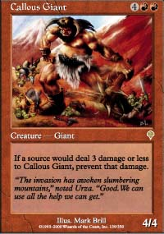
I'm feeling really good about this match, which is of course why I lose. I just can't find an answer to Lava Zombie in the first game and Callous Giant in the second despite having four methods of dealing with a four toughness red creature (not including blocking with Lava Zombie or Nightscape Familiar). My mana was okay, and the spells decent, but I didn't draw the ones I needed and at the 6-0 table, your opponent's decks are pretty unforgiving.
My confidence was a bit thrown with this loss as I really expected to go 8-0 with this incredible deck after pulling off two undefeated days with mediocre decks. All of a sudden I'm at risk of missing Day 2!
** Aside on GP New Orleans **
Astute readers may notice that I haven't mentioned the GP in between all these other Limited GPs where I did so well. GP New Orleans was in no way a disaster - I went 4-2-1 followed by 3-3 with a bye in the last round. But it wasn't a real success and most of my memories of that particular GP involve Bourbon street and topless women, but who wants to read about that?
** End Aside on GP Party! **
** Aside on Prevalent "Topless Women" Theme **
The more astute of you may have noticed the continual references to topless women throughout this and many other reports. While I could easily take a quick seven pages to rant about the inequities of a world where I am allowed to wander the street without a shirt while half of my fellow humans are not, I doubt that many would appreciate it. I would like to reassure the many sensitive viewers of my work that the mention of "topless women" in no way is intended to disrespect or objectify them but is merely used to describe the facts and situations that I find myself in at these events.
And to keep things fair, I'd like to mention the most beautiful men I've ever seen while walking along the streets of New Orleans. There was a transvestite strip club advertising "You Will Not Believe Your Eyes" and let me tell you, I didn't! Now before you make some scandalous assumptions about me wandering through Transvestite strip bars (not that there's anything wrong with that), two of the patrons-performers came out and crossed the street as we passed, thus giving me a glimpse into a world I never knew existed. While not inclined to explore the world of six-foot tall blonde men in heels and a bustier, I now have a better understanding of those who do!
** End random aside filled with enough gratuitous mentions of "Topless Women" **
6-1

Round 8 - Andrew Johnson
Andy is a nice guy and one of the Pittsburgh fellas/crew/posse/dudes. Pittsburghers (honest, that's what they call themselves!) are fantastic people in general, as I discovered at GP Pittsburgh last year, and Andy is no exception. The problem is that Andy wants to draw while I want to play with my amazing deck as much as possible. This led to a very tense situation in the third game where Andy REALLY wanted a draw and I felt horrible for playing, but I knew that if I drew I'd have to win one more the next day when my deck was likely to be much worse. Luckily this turned out to be an excellent decision for me!
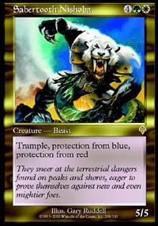
Andy's deck was a four-color special featuring Sabertooth Nishoba, but with the help of a mulligan on Andy's side in the third game I was able to win the match. The worst part was after the match when the Pittsburgh contingent cornered me in on the walkways of the hotel and held me over the railing while uttering various death threats. Mike Turian may look like a jolly fellow most of the time but he can get mighty fierce when angered!
7-1
End of Day 1
Day 1 ended on a bit of an exciting note for some of us as fellow Canadian Gary Krakower (also known as "my ride" and "my roommate") goes over the edge after being knocked out of second day by several subsequent top-decks. Gary decides he wants to go home immediately. Lucky for both of us there are lots of Canadians around and I just hook up with Canada's own 5/3 Artifact, Gab Tsang. The advantage to driving with Gab is that you're never stopped at the border - Juggernauts can't be blocked by walls! On the plus side, I get the double bed in the hotel room for a second night and Gary qualified for Barcelona on ranking!
I rush off for my six hours of sleep before Day 2 begins at 8:15 the next morning.

